**SMART LED THERMOMETER**

What is Smart Led Thermometer? It’s an Arduino project for third year students at Istituto Tecnico Informatica e telecomunicazioni (ITI) in italy. The idea behind the project is to create a device with Arduino capable of detecting humidity and temperature in the air, then to show on a LCD screen the numbers and at last to light a colored led based on the current temperature. This fun project will be able to get everyone acquainted with the Arduino IDE, writing software in general but most importantly to have hands-on experience with the Arduino hardware. A thermometer is always useful no matter what, the applications can go from being used at home to work within the context of a vegetable garden.

While following along in the explanation of the main aspects of the project it’s advised to look at the schematic of it. While all the wire connections may look intimidating, if we decompose it in main blocks by the end of the explanation everything will be clear.

By the end of this project the skills learned will be able to push everyone to greater heights in terms of future project difficulty and complexity.

**PART 1: HARDWARE**

In this section we’ll talk about the hardware component of the project, analysing the needed materials and the building blocks of the architecture.

First of all these are the components needed to start the project:

* Arduino Uno R3 x1
* 220 ohm resistors x4
* Blue LED x1
* Yellow LED x1
* Red LED x1
* DHT11 humidity/temperature sensor x1
* LCD1602 screen (with pin header) x1
* Potentiometer 10K x1 (needs basic assembling)
* 9V battery with snap-on connector clip x1 (needs connecting)
* Wires for connection x a lot (what’s inside the basic set is good)
* Female-to-Male Dupont wires x 16
* Bread board x1

Next we’ll analyze the three main blocks of hardware, without delving into the specific connections. To get a general overview of what we’ll be doing check out this circuit block:

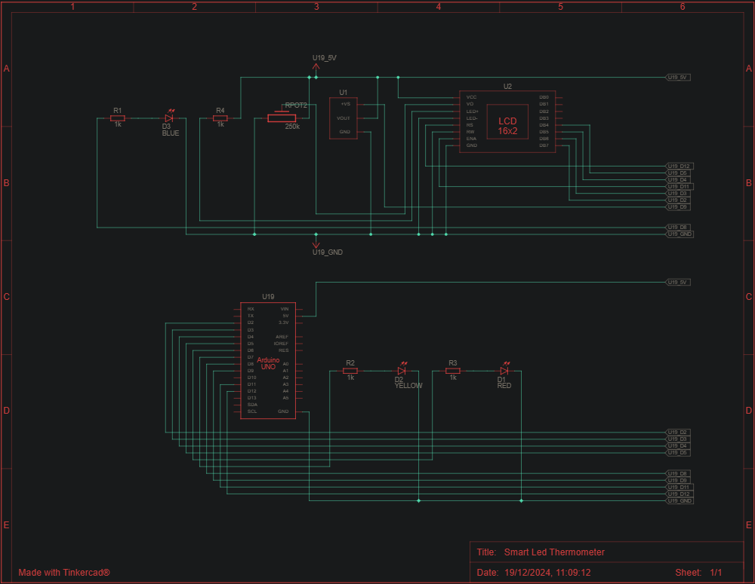

to get a clearer look at it with great detail you can always check the google drive folder: [Smart Led Thermometer Arduino](https://drive.google.com/drive/folders/1NuZAWTy1W9PAAMQJlDXOh0fy3PUO31KH?usp=drive_link).

First get accustomed with the terminology and the idea by reading the hardware section block by block, after having done that you’ll see the actual schematic of the project which while it may look intimidating, it should be much clearer now.

**Block 1) Humidty/Temperature sensor**

Starting from the humidity/sensor let’s create the connections between the microprocessor and the bread board, creating channels for the ground and 5V.

The sensor we are using as the backbone of our project will go in the upper left part of the breadboard. It requires only the ground, 5V and a pin to communicate its results to.

**Block 2) LEDs**

In the lower/middle left part of the bread board we’ll plug in 3 different colored LEDs, respectively blue, yellow and red. As mentioned before these lights will warn us at a glance of the current situation as far as the temperature goes. Creating the structure requires the resistors, the ground and the connection to three different pins. This is very similar to the creation of a semaphore so it could already be something familiar for many.

Technically speaking we could start working on the software part, directly lighting the right LED thanks to the already installed sensor, but where’s the fun in that? The final and most exciting part is the implementation of the LCD screen: the possibilities are infinite!

**Block 3) LCD screen**

In the right part of the bread board we will be creating the connections for the LCD screen. Through words only it’s hard to follow the numerous connections needed but by following the schematic it should be doable.

We are gonna be needing wires to the ground, to 5V and we are even gonna use a resistor. Some wires will go from the LCD screen directly to the digital pins.

The new component we’ll be using in this section is called a potentiometer. To put it simply it’s a component that will allow us to manually decide the brightness, intensity and definition of the LCD screen. It occupies 3 spaces on the bread board and it can be manually rotated from the top.

The last step to make the hardware work is to connect the battery to the correct connection on the Arduino Uno R3.

As promised here’s an actual look at the project schematic:

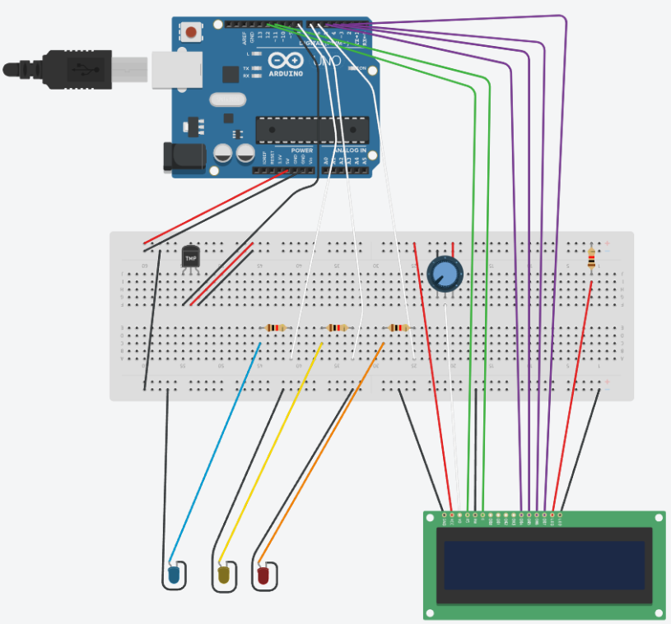

Just as before i recommend following the link:[Smart Led Thermometer Arduino](https://drive.google.com/drive/folders/1NuZAWTy1W9PAAMQJlDXOh0fy3PUO31KH?usp=drive_link). This will allow you to zoom in precisely in the section currently needed, something which is not really possible with a simple image.

**PART 2: SOFTWARE**

Now that the hardest part is out of the way, let's talk about the software component. First of all we’ll be using two libraries for this project: DHT sensor and LiquidCrystal. I’m not gonna go precisely into details here because it’s advised to consult the .ino file with all the code for reference and extensive documentation and comments.

To go through it briefly, we first initialize everything we need, from sensor to pins to LCD screen and in the loop, which is the core of the program, we write on the screen the gathered information and through some

if-else constructs we light the right LED based on the temperature.

The program is extensively documented line by line; the complex stuff is handled by the libraries. By understanding the hardware part of the project and by reading the comments everything should be clear.

**PART 3: CARDBOARD AND COMPLETION**

The only thing left to do is to create the cardboard box and to complete the project. By connecting through an USB cable Arduino to the computer it’s possible to upload the program on the microprocessor. Even after disconnecting it to the computer it will be still in memory. Thanks to the battery the project will work autonomously, which means the only thing left is the outer shell.

First of all we are gonna be needing a box of any type of material; if we go for a cardboard box then for the next steps we are just gonna be using scissors to make holes, hot glue and double sided tape to fix things in place. Just follow the next steps but instead of using the battery drill use your scissors.

As an example you may use an old shoes box or something along those lines, like one in the image:

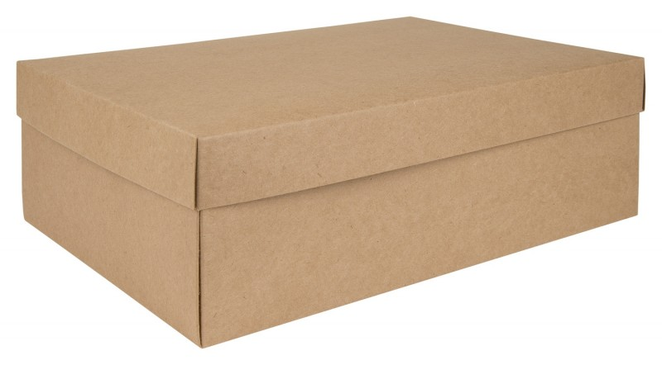

If otherwise we are gonna be using something made of plastic or similar, then we’ll need a battery drill and a small hacksaw. The images of the completed project will be shown at the end of this section not to create confusion. If you are interested in having a plastic box you can use one like in the image, easly purchased from Ikea.

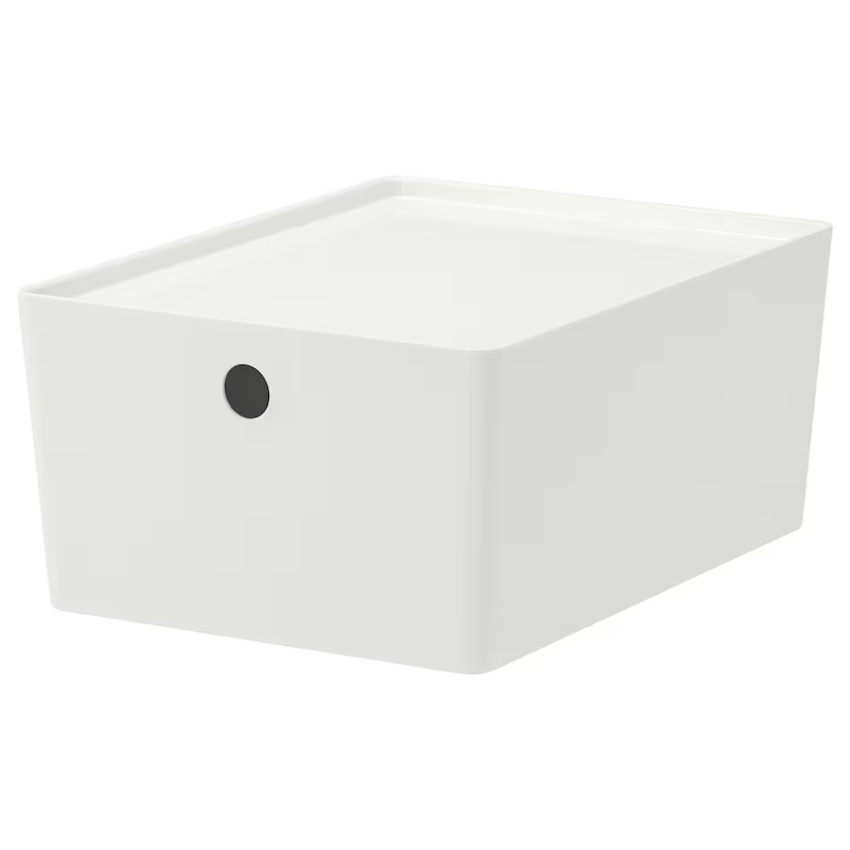

Before going any further I advise to take some measurements for the width of the LEDs and also for the width and height of the LCD screen. If you are unsure it’s better to have measurements a little shorter than a little bigger because if it’s shorter you can always iron out the imperfections. Having obtained the measurements draw on a side of the box the places where you’ll be making the holes, with a pen.

Let’s start by drilling three holes with the right width for the three leds. Just besides them we’ll make space for the LCD screen and through some holes and the use of a small hacksaw we’ll create the right space for the screen. If you don’t have any idea on how to do it don’t worry, simply follow what you already draw and start creating many holes, connecting them by using the hacksaw.

Same as before, using hot glue and double sided tape you can easly fix everything in place. In particular you’ll be using the glue for the LEDs and the LCD screen since they need to firmly stay in place. For the Arduino and similar components double sided tape will work just fine (remember that the breadboard comes already equipped with it and that you will need a thick tape for the arduino itself).

By doing this, the project is completed and now you’ll have your personal thermometer to be used wherever you want!

If you are here before reading the rest, here’s a sneak peak at the complete project!

(From above, three LEDs plus the LCD screen on the side, the cover is removable)

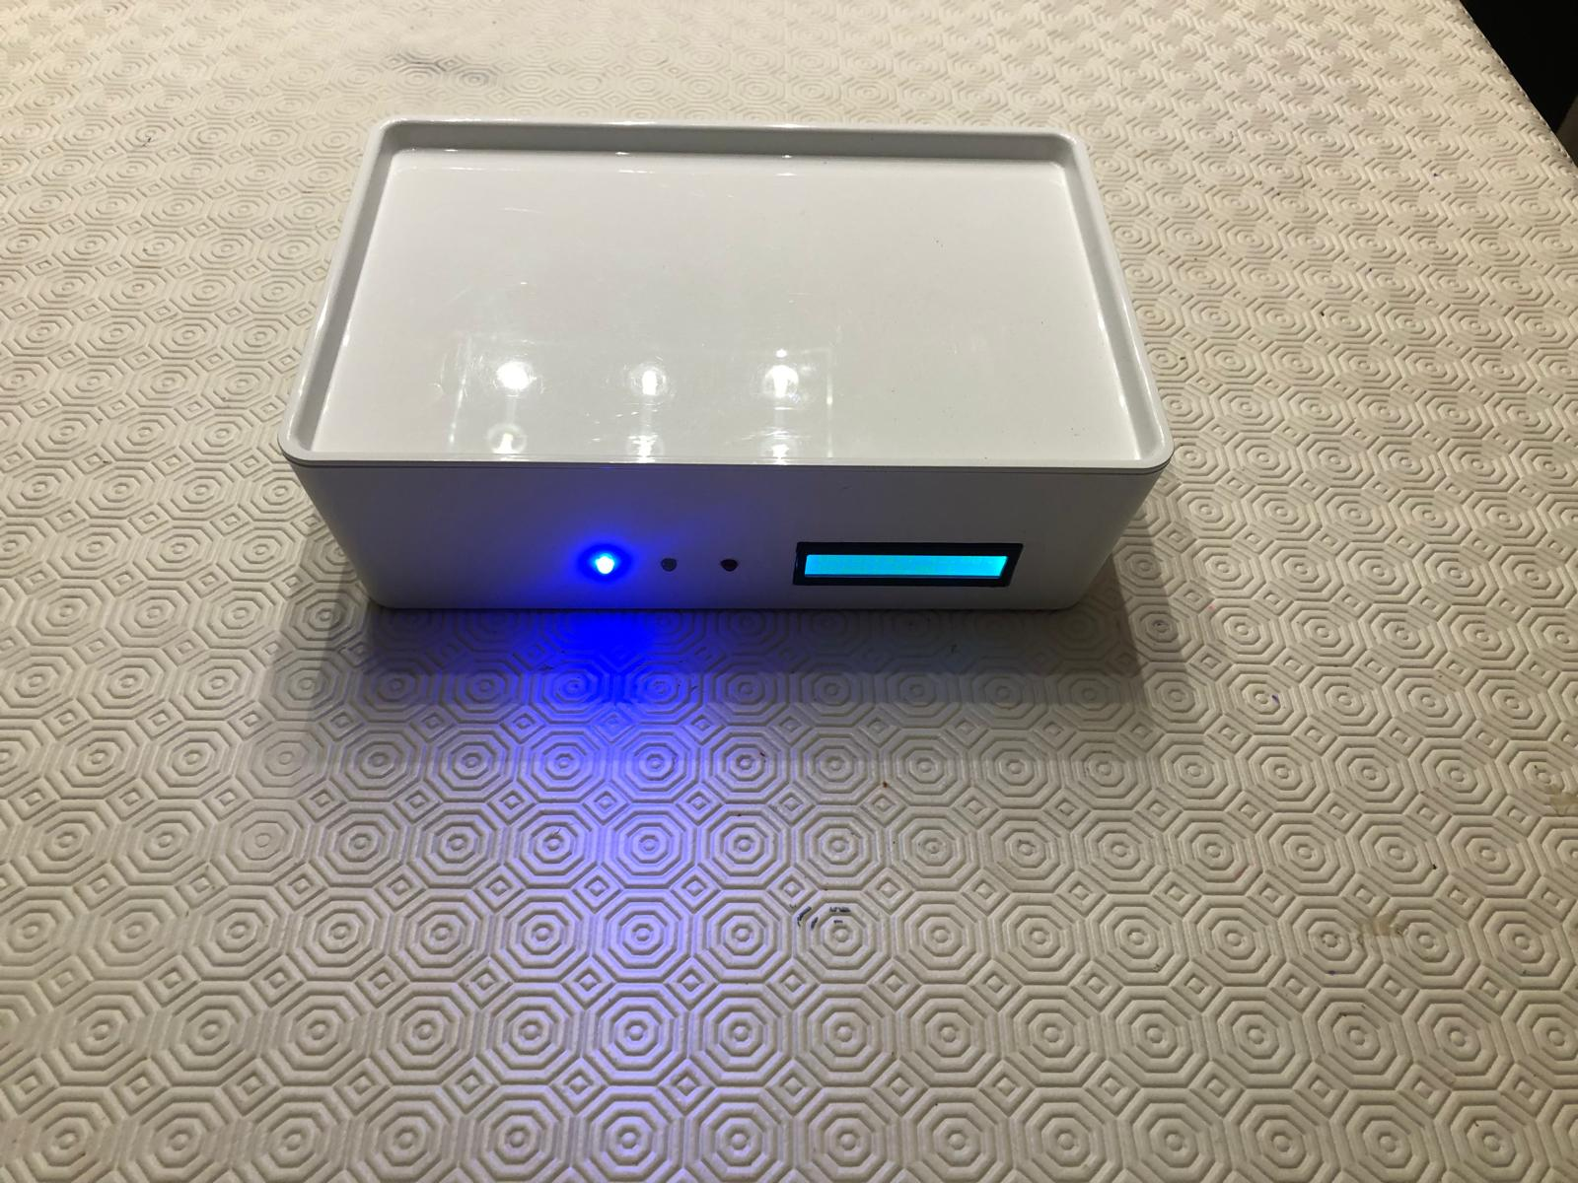

(Here’s a frontal view in detail, the LED is currently blue because it’s quite cold!)

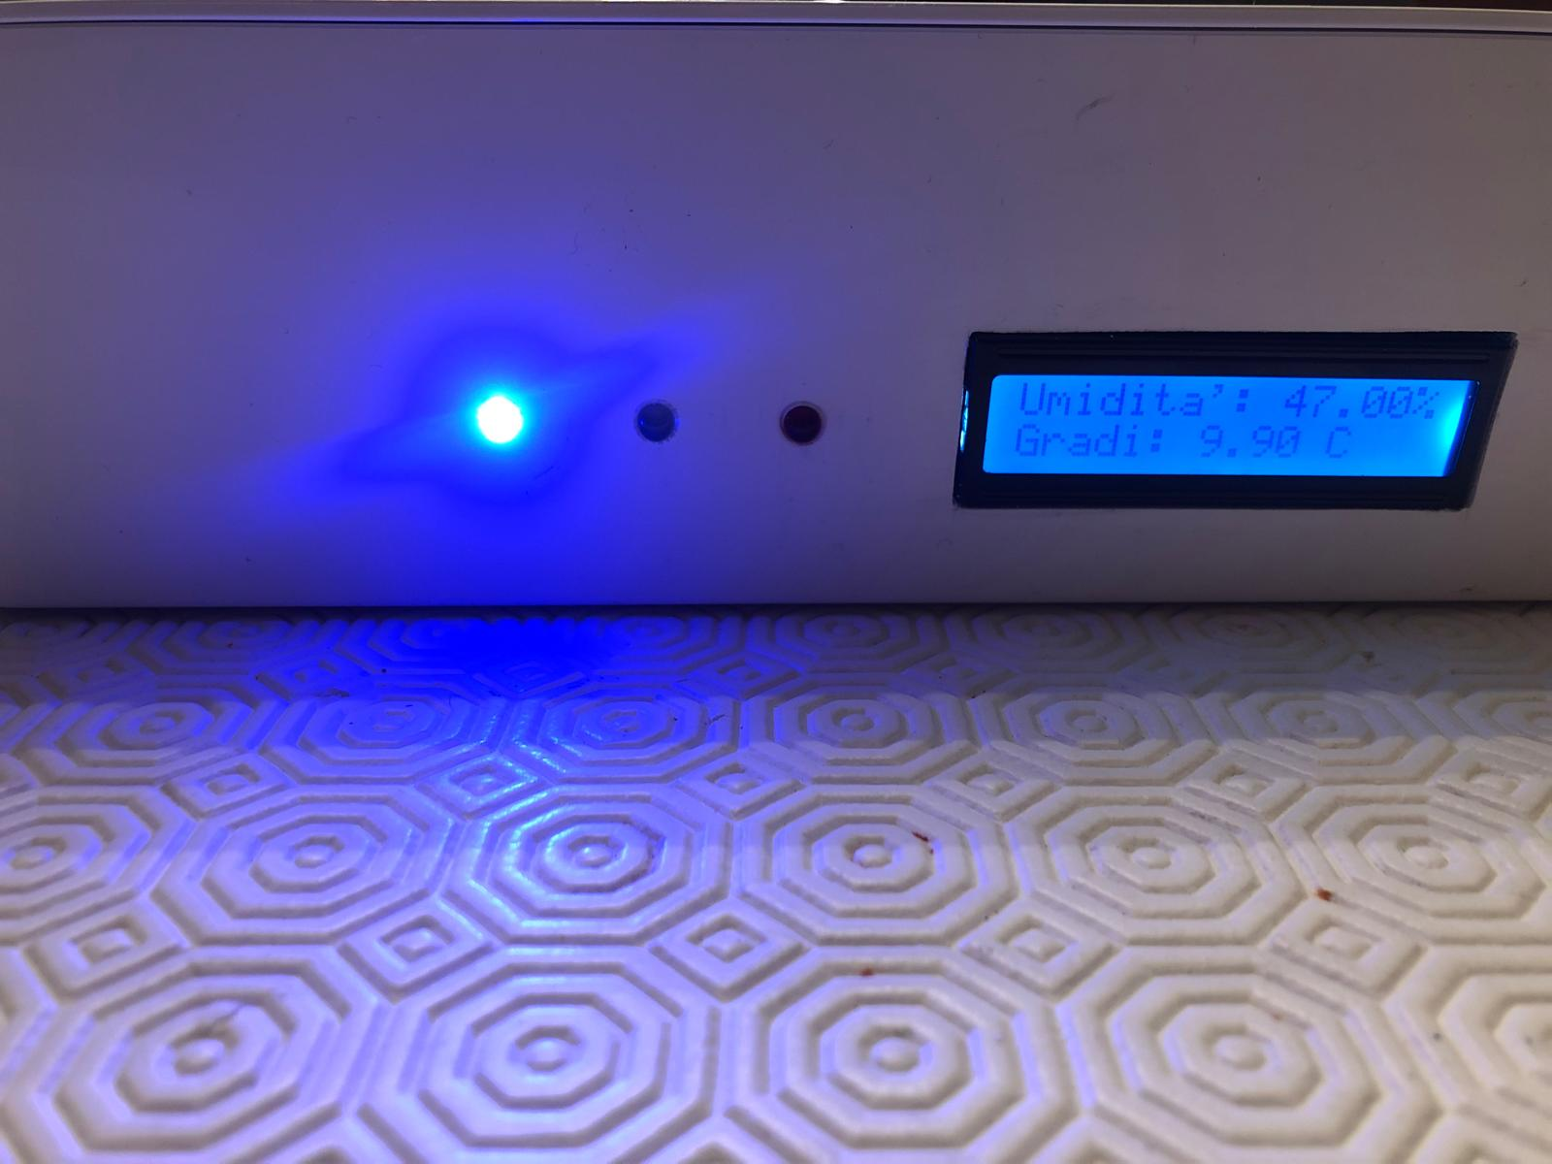

If you want to see how the smart led thermometer behaves at different temperatures, as well how it looks like in the inside check this video out!

(If you are reading this on google drive you can double click the image to watch the video, otherwise either click the link at the bottom or check mail attachments)



(Everything referenced here is on the google drive folder: https://drive.google.com/drive/folders/1NuZAWTy1W9PAAMQJlDXOh0fy3PUO31KH?usp=drive_link)